CREATE A MEAL PLAN FOR AN ATHLETE
- Think about a sports person you look up/aspire to be like- what is their name, what sport do they play……. Use the internet to find out some key facts about them- age, height, weight, hours they spend training every week…..
- Think about how many calories they are likely to burn during their training and competing.
- Using the NHS Eat Well Plate as a guide- but remember they will need to eat more than a non athlete as they will need extra energy-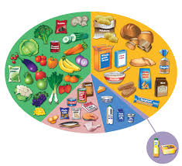
- Design a weekly plan for them:

 | Mon | Tue | Wed | Thur | Fri | Sat | Sun
Breakfast
snack
lunch
snack
tea
snack

Talk it through with someone in your class or family member to see if there is anything else you haven’t thought of!
Have fun, stay active, stay safe

