CREATE A NEW SPORTS CAPTAINS/LEADERS BADGE
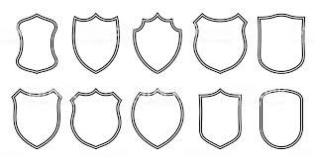
- At your school, there are sports captains or leaders- but how do you know who they are? They might wear a badge, or their pictures might be displayed somewhere, but could your suggestions be even better?!
- Pick your favourite badge outline from above- enlarge it onto a piece of A4 paper
- Think about the colours of your school
- Does it need any words or just pictures?

Talk it through with someone in your class or family member to see if there is anything else you haven’t thought of!
Have fun, stay active, stay safe

