DESIGN A NEW KIT
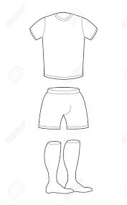

- Think about your favourite sport- could you design a ‘better’ kit for them to play in?
- Enlarge the templates if you want to- maybe think about a jacket too?
Talk it through with someone in your class or family member to see if there is anything else you haven’t thought of!
Have fun, stay active, stay safe

