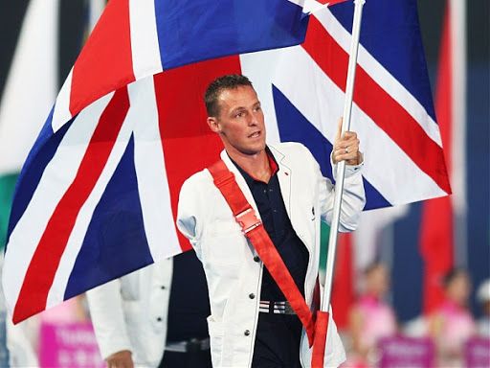
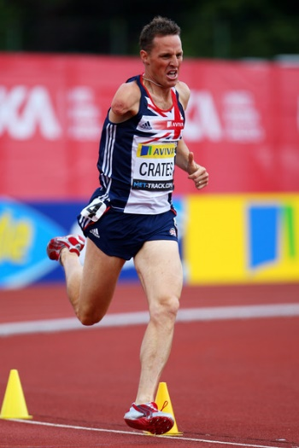
Star of the Week

Danny Crates

Daniel Brian Crates
(born 9 February 1973) is a former British athlete, who specialised in 800m sprinting. He is a former Paralympic world record holder in this event, and won gold medals in several international competitions, including the
Paralympic games, European Championships and World Championships. He was born in Orsett, Essex. He took up athletics after losing his right arm in a car accident while in Australia in 1994. He competed in T46 (arm amputee) events and represented Britain at the 2000 Summer Paralympics in Sydney – winning the bronze medal in the 400m sprint, and at the 2004 Summer Paralympics in Athens where he won gold in the 800m.
After Sydney,he switched from the 400m to the 800m, in which he holds the world record with a time of 1:53.27 set in 2004 at the AAA Championships.
Crates also won gold in the 800m race at the European Championships in 2003, and again in 2005. He won gold in the same category at the World Indoor Championships in 2003. He had previously won gold running 400m at the European Championships in 2001. He won gold in the 800m race at the inaugural Paralympic World Cup in Manchester in 2004, but did not compete to retain his title in 2008.
He also plays competitive rugby within teams of non-amputee players
Crates carried the Olympic torch in London in 2008 and was selected as flag bearer for the opening ceremony in the 2008 Summer Paralympics in Beijing.
His autobiography was published in 2012 and is called Danny Boy.

The Paralympic Games
Athletes with physical disabilities compete in these games and are called Paralympians. This includes athletes with mobility disabilities, amputations, blindness and Cerebral Palsy. There are Winter and Summer Paralympic Games. They are held just after the Olympic Games.

Challenges : 1. What is Goal Ball ? Who plays it?
2. Sitting Volleyball is a Paralympic sport, how many players in a team?
3. What events take place in the winter Olympics

Family Games
Boccia
Boccia is an inclusive game played in the Paralympic games. Did you know Daniel Bentley (born 15 August 1984 in Chelmsford) is a Paralympic boccia player with cerebral palsy. At the 2008 Summer Paralympics he was part of the first British team to win gold at boccia at the Paralympics?
Try playing this game sitting down, as they would do in the Paralympics.
Play against another player. If there are more than two people you can have two teams.
You can play this game with balls or rolled up socks.
You will need three socks/balls each and a marker? Jack (sock or ball of a different colour).
Place or roll the marker a distance away from your seated position.
Take it in turns to roll your sock towards the marker/Jack.
The ball that is closest to the marker is the winner.
You can alter the rules to make the game easier and harder
Space = put the jack closer or further away
Task = send underarm with palm facing up, send with palm facing down (with back swing) , send with your other hand, Play standing up , on one leg , sending through legs, sending backwards ?
Equipment –Get a bigger or smaller target, what else could you use to send towards the Jack?
People – have an umpire, play on your own ?
Click on the link below to see the video explaining how to play Boccia
https://youtu.be/WTT8fvh8la8
Balloon Volleyball
You will need a balloon. To make the net, draw a line on the floor using string or chalk or something long and straight in the house, like an ironing board?
The players sit either side of the net. Practice sending the ball over the net and keeping it in the air. Players must always remain with one part of their side or back or bottom touching the floor, so they cannot kneel up, stand up or push up on their hands so that part of their body is touching the floor.
To play, one player starts with the balloon and serves it over the net, the receiving player must return the balloon back over the net without letting it touch the floor.
You may tap, push, hit the balloon back over the net, with any part of the body, but not catch it?
One point for the player who manages to outwit their opponent and get the balloon to land on their opponents’ floor.
You can shuffle to move around the court, and lay down to hit the ball, but not stand up. First player to 11 points, wins the game.
Space- make the court smaller or bigger
Task – change the rules of the game – allowed to catch and send back, allowed two taps before sending back
Equipment - make the net higher – tie the string around the leg of two chairs ?
People - Have more people in each team if you have more people at home ?
Follow the link below to see our video on how to play.
https://youtu.be/sbEDyzsOBZk

Orienteering Challenge

Ks1 and KS2

Obstacle course

Task one

Set up a simple circuit in the house or garden to walk around.

(e.g walk through a door into another room, around a chair and over a cushion on the floor). As you travel give a commentary as though you are instructing someone through your circuit, use prepositional language like “over, through, around, beside, forward , backward, around and number of steps etc

Task two

Now try the same circuit with your eyes closed or wearing a blindfold scarf. Hold onto someone’s arm as they give you verbal instructions around the same circuit.

Task Three

See if you can be blindfolded and listen to instructions and navigate yourself around the circuit by just listening to instructions.

Space – change the layout of your obstacle course with different courses

Task – try the course backwards

Equipment – put different obstacle on the course

People – see if two of you can hold onto a piece of string and complete the course together?

Creative Challenge

KS1 Dancing Dice

Task 1 Roll the dice perform the number as on the dice.
Have 6 throws and perform each action for 30 seconds.

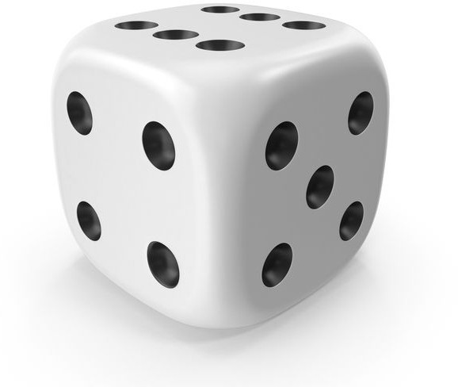

Task 2 select to go for:
Gold task –Until the total score on the dice add up to 40 . Perform each throw for 20seconds. Keep a total running as you perform.
Silver task -Until the total score on the dice add up to 30. Perform each throw for 20seconds. Keep a total running as you perform
Bronze total Until the total score on the dice is 20. Perform each throw for 20seconds and keep a total running as you perform.

Wiggle for 45

Gallop for 45 seconds

silly sailor 45 seconds

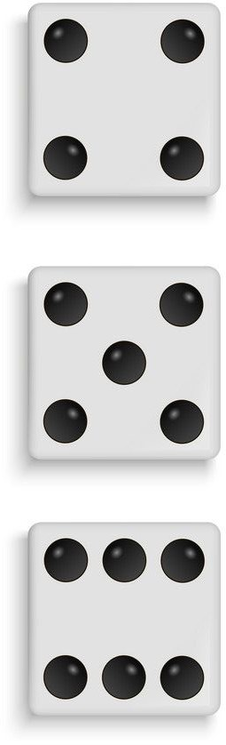
up the ladder 45 seconds

silly sailor 45 seconds

power ranger for 45 seconds

To find out how to do the actions visit
https://www.activekidsdobetter.co.uk/active-classroom
If you haven’t got access to the internet then make up your own actions for the numbers on the dice.

Creative Challenge

KS2 Dancing Dice

Task 1 Roll the dice perform the number as on the dice.
Have 6 throws and perform each action for 30 seconds.

Task 2 select to go for:
Gold task –Until the total score on the dice add up to 60 . Perform each throw for 20seconds. Keep a total running as you perform.
Silver task -Until the total score on the dice add up to 40. Perform each throw for 20seconds. Keep a total running as you perform
Bronze total Until the total score on the dice is 30. Perform each throw for 20seconds and keep a total running as you perform.

Cowboy squat 60 secs

Kick off 60 secs

Compass jumps 60 secs

Twinkle toes 60 secs

Heel tap 60 secs

Clap under leg 60 secs
To find out how to do the actions you can go to https://www.activekidsdobetter.co.uk/active-classroom

Or you can make up your own dance actions for the different numbers on the dice.

Skills Challenge

Skills Challenge
Table top cricket.

This weeks skills challenge is about accuracy and concentration. We have created a game that can be done inside on a kitchen/dining room table.
The image below shows how we set up our game.
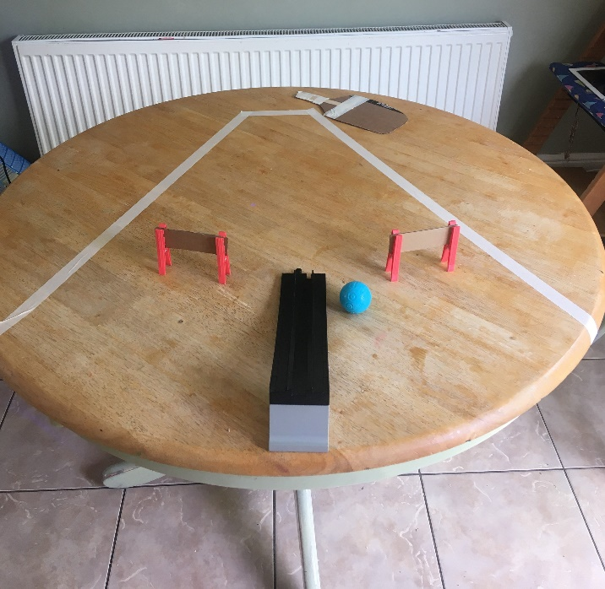
Batting Crease

Out of Bounds Line

Gates

Bowlers Ramp

Rules
- Batsman stands at the end where the batting crease is
- Bowler stands at the end of the ramp
- The bowler rolls the ball down the ramp towards the batsman.
- The batsman must wait for the ball to get to the crease before hitting the ball, we made a carboard bat reinforced with Lolly pop sticks, but you can use your palm or flick with your finger.
- Scoring
- – a ball hit through a gate scores 2 runs
- A ball hit over the edge of the table in without crossing the out of bounds line scores 4
- A ball that goes out of bounds doesn’t score.
- Each batsman faces 1 over (6 deliveries) then they swap over.

Challenge
Can you adapt the game to make it harder? Could the gates be fielders? Could the bowler be allowed to catch the ball if it comes off the table and score runs for catching it?

Go to www.Chelmsfordssp.com and see our demonstration video on how to play.

Check out our attempts on our twitter page @ChelmsfordSsp

Fitness Challenge

Agility Star Challenge

This weeks challenge is all about ‘Agility’ which means changing direction at speed.

Look at the diagram below of how to set up the challenge. Use what ever space you have and whatever you have as markers.

Starting in the middle you need to run as fast as you can to the first marker and back to the middle. You need to go to every marker and back to the middle. See what time you get and then try and beat it.

Challenge:

For a challenge can you change the shape of your agility course. Remember make sure the area is safe before doing any physical activity.
You can now follow the Chelmsford SSP on Twitter @ChelmsfordSsp where we will add videos linked to the weekly challenges.
Don’t forget to use the Legacy Chart to record the values you have shown this week. Write the date beside the values.
Good Luck everyone.

