Instructional Guide

QuadKids is an athletics event run every summer. This year we would like you to take on the Quadkids Challenge at Home or in School.
Quad Kids is suitable for children of all ages and is based around 4 very simple activities, Sprint, Jump a Run and Throw.
Each child will have their own score sheet (see below).
 | Time/Distance | Score | Running Total
Sprint
Jump
Bounce
Throw

Times and distances equate to points. Each event scores between 2 and 20 points(please see the full conversion sheet there are separate conversion sheets for KS1 and KS2).

Below are the simple instructions for the four events.
Sprint
A simple straight line sprint.
Years : EYFS, 1,2,3,4 50m sprint
Years : 5 and 6 75m sprint

If you don’t have access to an area big enough to complete in a straight line you can make up the distance in shuttle runs.
Jump
The jump for Quad Kids is a standing long jump.
Make a line to jump from, put your toes right up to the line, bend low and swing your arms. Jump as far as you can. You must measure from the nearest point to the start line (see below).
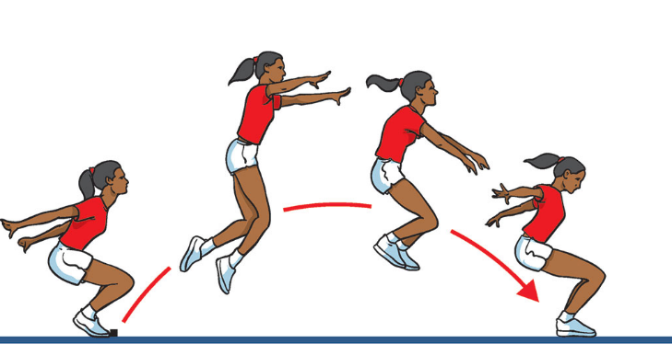

Bounce
We want to see how many speed bounces you can do in 20 seconds. A speed bounce is a 2 footed jump from side to side over a low barrier. They only count if they are a 2 feet to 2 feet jump.

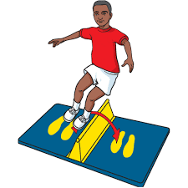

Throw
We would like you to measure a tennis ball throw from a standing position (No run ups allowed). Measure in meters and centimetres from the throwing line to where the ball first touches the ground and not where it rolls too.
IMPORTANT: If you are doing this in school each child taking part should have their own tennis ball, you shouldn’t share equipment between children and equipment should be cleaned between uses.

