Star of the Week!
Liam Ansell
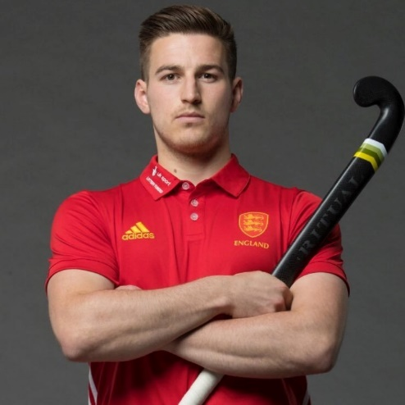

Liam Paul Ansell (born 12 November 1993) is an English international field hockey player who plays as a forward for England and Great Britain. Representing his country at the 2018 Commonwealth Games, Ansell helped the team to win a bronze medal. He then continued to shine during the 2018 World Cup, claiming a fourth-placed finish and producing some spectacular goals along the way.

Physical Challenge: Ansell always uses his brilliant hand-eye coordination. Use rolled-up socks to aim at a target, even with your eyes closed!
Research Challenge: Research how many people are on a Hockey pitch at one time. What are the different positions in a Hockey team?

Creative Challenge: try making yourself a hockey stick out of things you can find at home and practice dribbling round a circuit with a ball or rolled up socks.

Creative Alphabet
Gymnastics lesson for home or school.

Warm Up activity
Move continuously for 5 minutes. Begin by walking fast from your staring spot for 10 large strides and back again. X lunge X lunge
Do this for 1 minute, stopping to do a lunge step on each leg when you get back to each end.
Next jog around the outside of your area for2 minutes , stopping and doing a quadricep stretch when passing your start position. To do the stretch, stand on one leg and take the heel of your other foot behind you and hold onto it for 10 seconds. You should feel the stretch in your thigh. Repeat with the other leg.
Quad stretch x

Now gallop for 1 minute. Gallop for ten strides one way and do a side stretch and gallop back and do a side stretch on the other side.
Side stretch side stretch

Now find you own way of travelling for 1 minute and link with an arm stretch at the start and finish of your pathway.

Skill Focus
Make the letter T with your body using your arms and legs. Make it standing up on a high level. Make it lying down at a low level . Can you make it at a medium level?
Check your arms and legs are tight and tense and your letter is as neat as you can make it.
Now explore making the following letters Y ,L,V,I,O at a high, medium and low level. Extend your arms and legs and make sure your toes are pointed. Hold each shape for 5 seconds.

Development
Can you take the following actions and link them smoothly into a sequence?
2 letters , 2 ways of travelling on feet, 2 jumps , 1 balance .
KS1 – Perform your sequence with an adult reminding you of the actions. Practise and see if you can move smoothly from one action to another.
LKS2 perform your sequence and repeat it until you can remember it. Check for pointed toes and smooth transitions between actions. As you perform describe your movements as if you were doing a commentary for the television.
UKS2 perform the actions fluently and with consistent control. Include a change of levels, pathways, and speed in your sequence. Write down and describe the actions, for someone else to perform your sequence.
You could video your sequence and look for improvements on your performance.

Cool Down
Stretch and curl to relax.
Lie down on your back and slowly stretch your arms above your head and extend your legs away from your body, keeping them tightly together and your toes pointed. Hold this straight stretch for five seconds and then slowly bring your knees up to your chest into a small ball, hugging your knees with your hands. Stretch and curl five more times to relax.
Still lying on your back extend your arms and legs out wide in a straddle position making the letter X. Hold the stretch for five seconds and then roll onto your tummy and take your arms off the ground in front of you and your legs off the ground behind you – to make a U shape. Repeat rolling onto your back in an X and onto your front for a U four more times.
Challenges:
Space - alter the pathways in your sequence e.g. wiggly, zig zag, spiral, straight. Change the distance you travel. Change the levels you use.
Task - perform your actions at different speeds or add more actions in your sequence
Equipment- Use markers to help you perform your sequence and know where to start and finish. Use ribbons to twirl as you perform your actions, like a rhythmic gymnast. Perform your sequence to music.
People- Teach your sequence to another person and staying 2 meters apart perform at the same time. Can you perform both your partners sequence and your sequence one after the other?

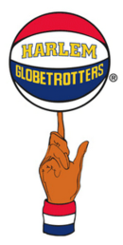
Game Challenge
Globetrotters
To be a successful player in basketball you need to be physically fit to run up and down the court and you also need good hand eye skills, being able to control the ball in both your left and right hand. Watch the Harlem Globetrotters on YouTube!

This competitive game will improve both your hand eye skills and your fitness levels.

Player one always stands at least two meters away from player two.

Player one completes a skills challenge as fast as they can called “round the world”. They do this by passing the ball around their head 10 times, round their waist 10 times and around their ankles 10 times. See video example on Chelmsfordssp.com/parentzone/physical challenges or click below https://youtu.be/YciDGX2H_mc

Player 2 must dribble the ball up to a marker and around the marker (10 strides away) and back again. Each time they finish a length they count “1, 2, 3” and so on. See video example.

To start the game, one player shouts “go”. Player one completes the Round the world skills challenge as quickly as possible , whilst Player 2 dribbles the ball up and down the lengths as fast as they can to see how many laps they can make before player 1 finishes and shouts “STOP “. Player 2 announces how many laps they achieved.

The players then change roles, both keeping hold of their own ball. They play the second half of the game to see who has the most laps at the end of the game.

Instead of shaking hands, which is not allowed yet, players can gesture a handshake and say “well done”, to show good sporting spirit and then perhaps challenge each other to a rematch.

Differentiation:
Space - change the distance you are from the target, make the pathway zig zag rather than straight
Task – Change the skills player 1 completes or change the rules of the game.
Equipment – use a smaller ball, dribble round markers
People – If players are different ages or the ability levels are different, make the rules harder for the more able player.

Fitness Challenge
Rock, Paper , Scissors , Forfeit

This is bringing a fitness element to the classic game of Rock, Paper , Scissors.
The game is simple two players facing each other thinking of social distancing where appropriate chant Rock , Paper , Scissors then using their hand make the symbol representing their choice.
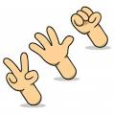

This is where the ‘Forfeit’ of the game comes in. If you lose the winner chooses a forfeit for their opponent. Example forfeits are shown below.
- Run to the nearest tree and back
- 10 Star Jumps
- 10 Sit ups
- High Knee running for 30 seconds
- Shadow boxing for 30 seconds

Differentiation:
Space - change the distance you use to do the forfeits in. Older children can run further increase the challenge
Task – Change the actions, get creative with your partner can you come up with extra hand signals.
Equipment – If you are able to include equipment in your forfeits remembering to use your own equipment and not to share.
People – Can you increase the game to 3 people in a game, or play a tournament.

Skill Challenge

Trick Shot Challenge

This weeks skill challenge requires you to be as creative as you can.

The task is to create a trick shot using any equipment you have either at home or that you can use at school.

Can you break down the skill into teaching points, so that others could learn how to perform your trick shot.

Below is my trick shot – a video of which can be seen on the www.chelmsfordssp.com parent zone.

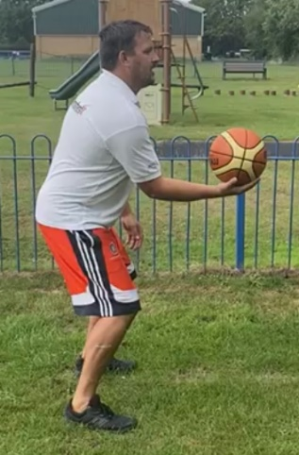
1 – Hold the ball out in front of you with your knees bent.

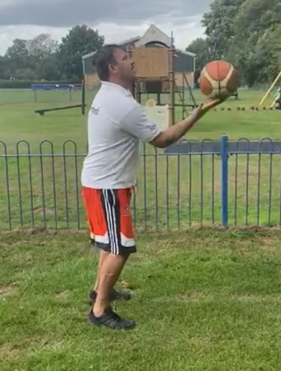
2 – Start to flick the ball over your head trying to put a forward spin on the ball, as shown by the arrows.

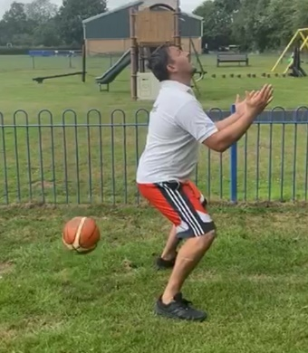
3 – Let the ball bounce behind you , bend your legs and look up ready for it to come back over your head.

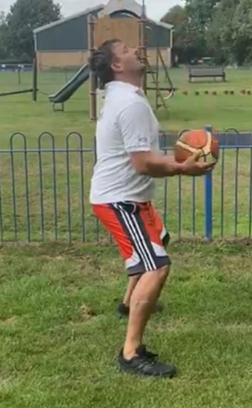
4 – Get ready to catch the ball.

See if you can use my teaching points to learn how to do my trick shot. Have fun creating your own and remember to write out your teacher points so that your friends can copy you.

Virtual Competition
Quad Kids
The quad kids competition is still up and running, you have until Friday 10th July to get your scores into to us via your school. The full Quad Kids resource can be found on www.chelmsfordssp.com but below are the simple instructions for how the four events work.

Sprint
A simple straight line sprint.
Years : EYFS, 1,2,3,4 50m sprint
Years : 5 and 6 75m sprint

If you don’t have access to an area big enough to complete in a straight line you can make up the distance in shuttle runs.

Jump
The jump for Quad Kids is a standing long jump.
Make a line to jump from, put your toes right up to the line, bend low and swing your arms. Jump as far as you can. You must measure from the nearest point to the start line (see below).
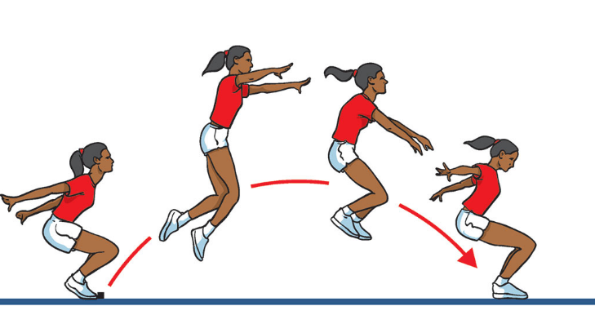

Bounce
We want to see how many speed bounces you can do in 20 seconds. A speed bounce is a 2 footed jump from side to side over a low barrier. They only count if they are a 2 feet to 2 feet jump.

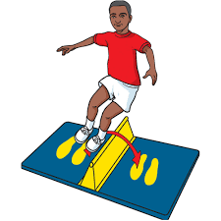
Throw
We would like you to measure a tennis ball throw from a standing position (No run ups allowed). Measure in meters and centimetres from the throwing line to where the ball first touches the ground and not where it rolls too.
When you have done the events look at the conversion sheet and give each result a score. When you have all four scores you can send it into your class teacher.

