Star of the Week
Usain Bolt
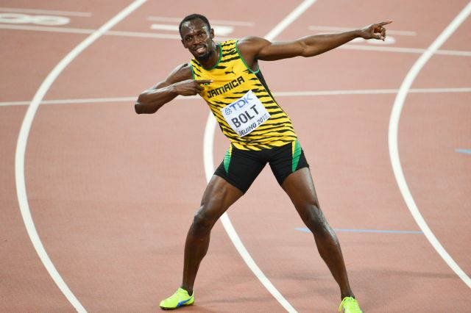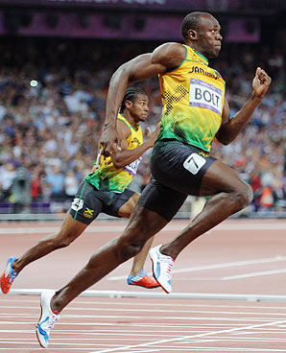
Usain St Leo Bolt,( born 21 August 1986) is a Jamaican former sprinter. He is a world record holder in the 100 metres, 200 metres and 4 × 100 metres relay. Owing to his achievements and dominance in sprint competition, he is widely considered to be the greatest sprinter of all time.
Resilience
Usain Bolt had to work hard to become the fastest man in the world. He can run 100m in 9.58 seconds.

Physical Challenge:
How far can you run in 10 seconds? Measure your first attempt and see if you can get further each time.

Creative Challenge:
Usain had a trade mark action after he finished each race (see above). Make up your own victory sign for when you finish a race.

Early Games (EYFS)Challenge Chart:
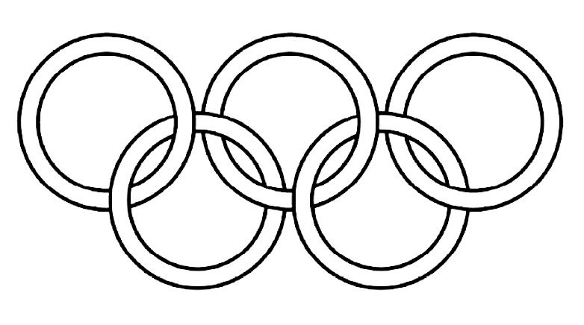

Draw pictures in the rings of your doing the five challenges

Early years Games Challenges:
All completed on a 10 m track, 2 meters away from the next person.
- Sprinting: Running your fastest – sprint down the 10 m down track touching the floor at the end and running back, repeat so that you will have done 40 meters of running in total.
- Two footed jumping: doing your strongest, fastest jumping – jump down the 10-meter track to the end, touch the floor and jump back.
- Side stepping: stand sideways and travel down the track side stepping. Touch the floor and sidestep back.
- Big strides – using your biggest step – do giant strides down the track, touch the floor and do giant strides back.
- Hippity hops - hop on one leg 3 times and then the other leg 3 times as you travel down the track. Keep hopping until you get to the end and touch the floor. As you travel back have a go at the pattern step hop , step hop, all the way back (skipping action).

Tiny Games Yr1 Challenge Chart:

Draw pictures in the rings of your doing the five challenges

Yr 1 Tiny Games Challenges:
All completed on a 10 m track, 2 meters away from the next person.
- Sprinting: Running your fastest – sprint down the 10 m down track touching the floor at the end and running back, do this three times, so that you will have completed 60 meters of running in total.
- Jumping: doing your strongest, fastest two footed jumping – jump down the 10 meter track to the end doing, touch the floor and then try doing hop scotch jumping on the way back, which is 2 footed jump, hop, 2 footed jump, hop.
- Side stepping: stand sideways and travel down the track side stepping. Touch the floor and sidestep back, repeat so that you have done 40 meters in total.
- High and Low : Get down on your hands and feet and find a way to travel down the track using just your hands and feet. At the end stand up and travel back by doing big leaping strides.
- Hopping - hop on one leg 5 times and then the other leg 5 times as you travel down the track. Keep hopping until you get to the end and touch the floor. As you travel back have a go at the pattern step hop, step hop, all the way back (skipping action)

Lower KS2 Athletics Challenges:
All completed on a 10 m track, 2 meters away from the next person (time the running events if possible).
- Sprinting: Sprint down the 10 m down track touching the floor at the end and running back, repeat 4 times so that you will have run 80 meters in total.
- Hop, Jump: travel down the track doing a hop on your right leg , then stay on your right leg as you jump forwards to land on 2 feet( hop jump action). Now hop on your left leg and then stay on your left leg as you jump forwards to land on two feet. Try and jump as far as you can with each action . Touch the floor at the end and do the same actions back. Repeat so you will have done 40 meters of hop,jumping.
- Skipping – travelling as fast as you can skip to the end of the track and skip back. Repeat 4 times so that you will have completed 80 meters of skipping.
- Side Stepping – travel down the track sidestepping, touch the end and sidestep back. Repeat 2 more times so that you will have completed 60m of side stepping.
- Distance running – jogging slowly down the track and back again (1 lap) now repeat a further 9 times so you will have completed 200m in total.
- Standing long jump – how many 2 footed long jumps does it take you to reach the end of the track. Try and jump further each time as you return to the start.
Lower KS2 Athletics Challenges Personal record Chart
Fill in the chart for a week : See if you improve.
EVENT | Day 1 | Day 2 | Day 3 | Day 3 | Day 5
Sprint
(Record time)

Hop Jump
(Least number to complete 1 length of track)

Skipping
(Record Time)

Side Stepping
( Record time)

Distance
(Record time)

Long Jump
(least number of jumps down one length of track)

Upper KS2 Athletics Challenges:
All completed on a 10 m track, 2 meters away from the next person (time the running events if possible).
- Sprinting: Sprint down the 10 m down track touching the floor at the end and running back, repeat 5 times so that you will have run 100 meters in total.
- Triple Jumping: travel down the track doing a hop, step and jump. Try and make each action as long as you can. Touch the floor at the end and do the same actions back. Repeat so you will have done 40 meters of triple jumping.
- Skipping – travelling as fast as you can skip to the end of the track and side step back. Repeat 4 times so that you will have completed 80 meters.
- Hop scotch – travel down the track doing a hop scotch action. Touch the end and hop back on your right leg. Repeat the hop scotch action again, but hop back on your left leg the second time.
- Distance running – jogging slowly down the track and back again (1 lap) now repeat a further 9 times so you will have completed 200m in total.
- Standing long jump – how many 2 footed long jumps does it take you to reach the end of the track.Try and jump further each time as you return to the start.

Upper KS2 Athletics Challenges Personal record Chart
Fill in the chart for a week : See if you improve.
EVENT | Day 1 | Day 2 | Day 3 | Day 3 | Day 5
Sprint
(Record time)

Triple Jump
(least number to complete 1 length of track )

Skipping
(Record Time)

Hop Scotch
( Record time)

Distance
(Record time)

Long Jump
(least number of jumps down one length of track)

