This is to certify that

...................................................................................................................
participated in the virtual
National School
Sport Week

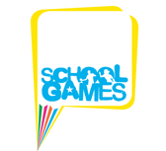

Sara Robson
School Games Organiser Chelmsford School Sport Partnership

June 2020

