Star of the Week
Victoria Pendleton
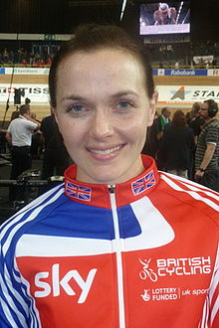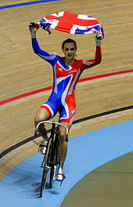

Victoria Louise Pendleton, CBE (born 24 September 1980) is a British jockey and former track cyclist who specialised in the sprint, team sprint and keirin disciplines. She is a former Olympic, World, European and Commonwealth champion. With two Olympic gold medals and one silver, Pendleton is one of Great Britain's most successful female Olympians.
Pendleton represented Great Britain and England in international cycling competition, winning nine world titles including a record six in the individual sprint, dominating the event between 2005 and 2012. In 2008 she won the sprint in the Beijing Olympics, and in 2012, she won the gold medal in the keirin at the London Olympics, as well as silver in the sprint.

Physical Challenge:
Ride your bike or scooter to the park and see how long you can cycle or scoot for ?

Research Challenge: Which male cyclist has the most Olympic medals for Great Britain?

Creative Challenge:
Design your own school cycling top. There is a template on the website if you need it.

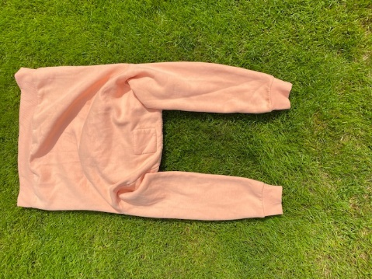
Sweatshirt Agility Challenge

It is important in any sport to be agile and fit. Footwork and ladder skills are a good way of improving your speed, strength, and agility. There is a physical challenge on the website, of how to use your own sweatshirt or jumper to do an agility activity.
Have a go and see how quickly you can do it. https://youtu.be/RLOMNM84Okg
Challenges:
Space : Put several jumpers down in a row and complete a longer challenge
Task : Teach someone else your own pattern of footwork. Change the actions to hopping. Time yourself to get quicker. Increase the number of repetitions
Equipment : use other items of clothing to make a different agility circuit
People : complete your pattern at the same time as a friend in unison. Race a partner.

Umbrella Golf Challenge
You will need a golf club or an umbrella, a plastic cup, and a golf ball (or rolled up piece of foil).
There are many games where you need to have good aiming skills. In golf you have putt the ball into a hole. The person who takes the least number of shots is the winner.
Make up a golf target scoring game, seeing how many shots it takes you to putt the ball into a plastic cup or towards a target.
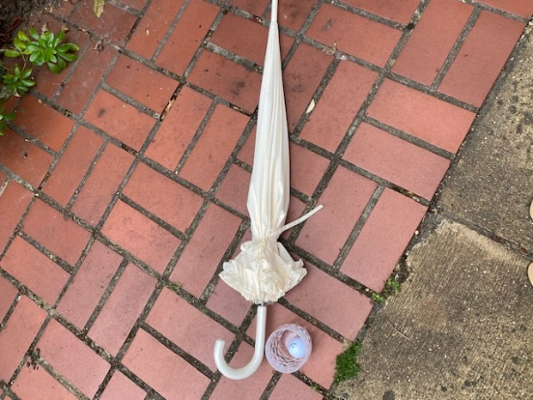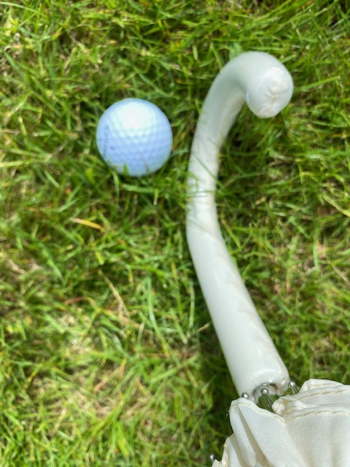

Rounders Challenges
Rounders is a fantastic summer sport which relies a huge amount on good hand eye co-ordination. Below are challenges that would have transferable skills to help you become great at Rounders.

KS1
X marks the spot
This is a throwing/aiming game. All you need is a wall and a small ball to throw (a tennis ball would work perfectly).
If you are using an outside wall and have chalk mark an ‘X’ on the wall about chest high. You could use a small ball of blue tack if inside.
Take 3 big steps back from the wall.
Aim and throw the ball at the ‘X’ . You get 3 attempts at hitting the mark.
- If you hit 2 or 3 times try another step back
- If you score 1 out of 3 you can stay at the same distance from the wall.
- If you miss all 3 your next attempts can be a step closer.

Ball Balancing
For this challenge you need a small ball around tennis ball size, some sort of wide flat bat, you could use a tennis racket, or a wide hard back book would work perfectly.
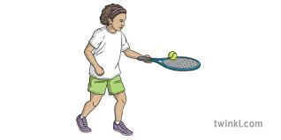
Challenge 1 – How long can you keep the ball balanced on you bat without it falling off. If this is too easy can you keep it balanced and walk about whilst keeping the ball on your bat.

Challenge 2 – can you roll the ball around the edge of your bat/book without the ball falling off.

KS2
Quick Catch and Release
For this challenge you need a wall and a tennis ball.
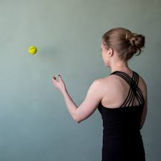

For all of the challenges you need to be 2-3m back from the wall you are throwing at.

Challenge 1 –
Throw with your strong hand and catch 2 handed. How many can you do in 30 seconds.

Challenge 2 –
Throw and catch one handed, use your strong hand. How many can you do in 30 seconds.

Challenge 3 –
Throw and catch from one hand to the other, practice throwing with your weak hand as well as your strong hand.

Hitting zone.
For this skill challenge you need a ball (tennis ball would work fine) and a bat that you can hold in one hand. A rolled-up magazine would work fine as a rounders bat. You also need to make 3 gates , you could use rolled up socks, tea towels anything that would be easy to see.

Set up below:

3m

3m
3m

Challenge 1 – Holding the bat in a forehand grip can you hit the ball through all 3 gates, you have 5 attempts to score 3 successful shots. You can self feed the ball or is possible have the ball bowled to you.
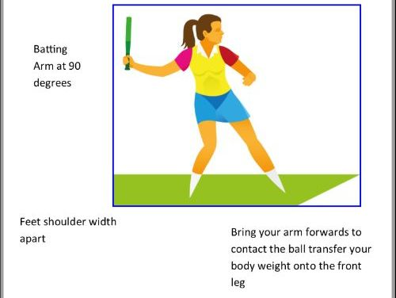

Challenge 2– Holding the bat in a backhand grip can you hit the ball through all 3 gates, you have 5 attempts to score 3 successful shots. You can self feed the ball or is possible have the ball bowled to you.
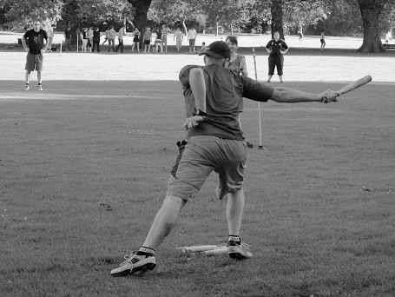
Football Skills Challenges
Football is the most popular sport in this country. It needs stamina, speed agility as well as skill.
Follow the link below to see lots of videos of football skills you can try.
https://www.bbc.co.uk/cbeebies/watch/playlist-football-skills

KS1
Toe Taps
All you need for this challenge is a ball any sort would work well.
With the ball in front of you put one foot on top of the ball , then swap over which foot goes on top. See how quickly you can change your feet over.

Shuffle
With the ball between your feet pass the ball between each foot keeping control as you pass it from foot to foot.

KS2
Trap and pass

All you need for these skill challenges is a football and a wall.
Challenge 1 – Standing 3-4m back from the wall . Pass the ball against the wall as it comes back to you trap the ball and pass it again. It’s really important to control the ball as quickly as possible so you can pass it as soon as possible.

Challenge 2 – Pass the ball against the wall trap the ball and pass it using the other foot. Keep alternating which foot you both trap and pass the ball with.

Challenge 3 – Can you now keep the ball being passed against the wall without trapping it. Passing the ball in a controlled manner will help you be successful in this challenge.

