Archery Set Up Instructions

Step 1 – Set up target
Open the box, both halves will separate (see image 1). Using the two black brackets slide them into the slots of the base (see image 2). Put the target half of the box into the brackets (see image 3).
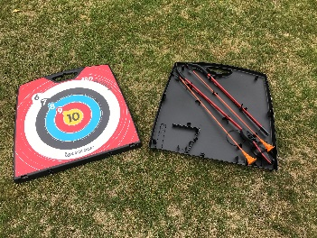
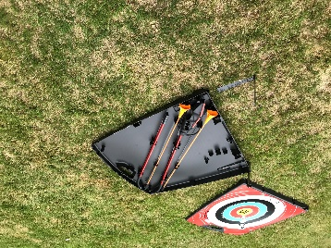
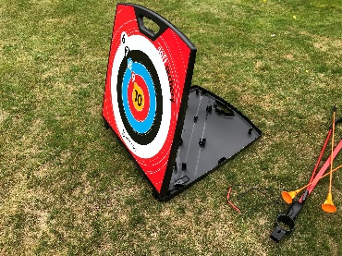

Step 2 – Build bow
Take both parts of the below and slot together as shown below (see image 4).
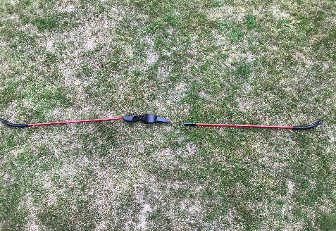

To string the bow, hook the string over one end (see image 5). Bend the bow to string the other end (see image 6)
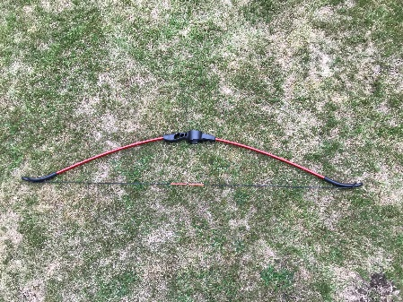
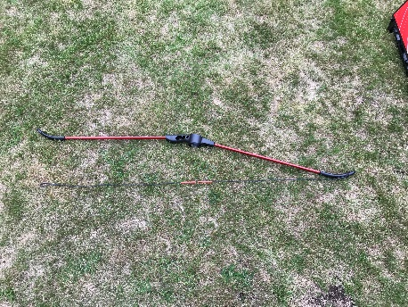

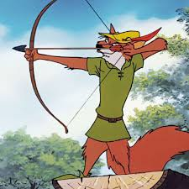
Archery Virtual Competition

Safety | These bows are very powerful, it is vital that you make sure the firing range is clear before anyone enters the area to collect arrows. Make sure you leave enough space between targets (at least 3 m)
Team Criteria | A team is made up of 2 Girls and 2 Boys
Rules | KS1 – 4 meters  Lower KS2 – 5 meters  Upper KS2 – 6 meters  Each member of the team shoots 2 arrows and their score is collected, after all 4 members of the team have fired their 2 arrows (8 arrows altogether as a team) the score is totalised  Points for each scoring zone can be seen below.  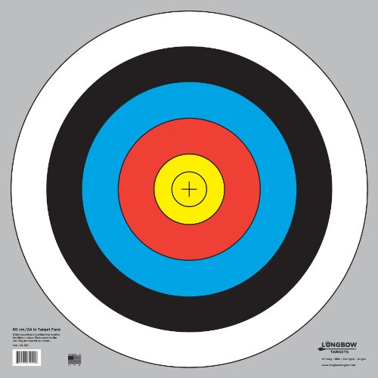  4 6 7 8 9 10
Level 2 Competition | Send in the results for your best teams to cssp@gbhs.co.uk Please include what year group they are in.

