

This is to certify that

**…….....................................................................**



**Participated in the Chelmsford SSP**

Skipping

Competition

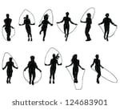

*Sara Robson*

**School Games Organiser Chelmsford School Sport Partnership**