

This is to certify that

**..................................................................**



**Participated in the Chelmsford SSP**

Speedstacks

Competition

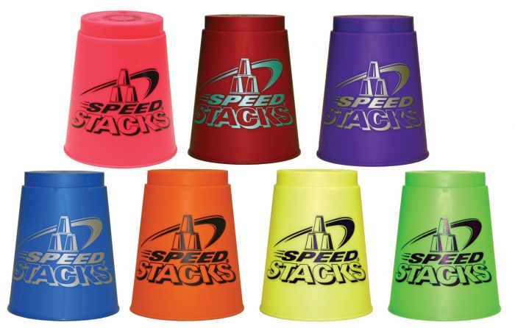

*Sara Robson*

**School Games Organiser Chelmsford School Sport Partnership**