

This is to congratulate

**________________________________**

**Achieving …….. place**

**in the ‘Enter Year Group’**

**Cross Country**

**VIRTUAL COMPETITION**

**‘Enter Year’**

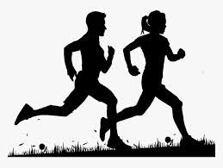

*Sara Robson*

**School Games Organiser Chelmsford School Sport Partnership**