

This is to certify that

**...................................................................................................................**

**Took part in the**

**[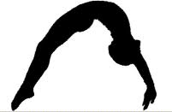](http://www.google.co.uk/url?sa=i&rct=j&q=&esrc=s&frm=1&source=images&cd=&cad=rja&uact=8&docid=T1_NGFzbuzFkrM&tbnid=wuhN5aJ_NSgZWM:&ved=0CAUQjRw&url=http://www.pinelandsgymnastics.com/CAMPS.html&ei=FVPOU6LECsOq0QWni4HICQ&psig=AFQjCNHX3Au41Q_vddsXbMmas5VKBrogRA&ust=1406116998351858)**

**Virtual Gymnastics**

**Competition**



*Sara Robson*

**School Games Organiser**

**Chelmsford School Sport Partnership**