This is to certify that

...................................................................................................................
Achieved …………… place at the
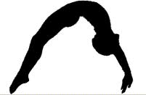
‘Enter Year Group’
Virtual Gymnastics
Competition
‘Enter Year’

Sara Robson
School Games Organiser
Chelmsford School Sport Partnership

