Team A ……………………………. Team B………………………………
Archer No | Round 1
1
2
3
4
Total
Grand Total
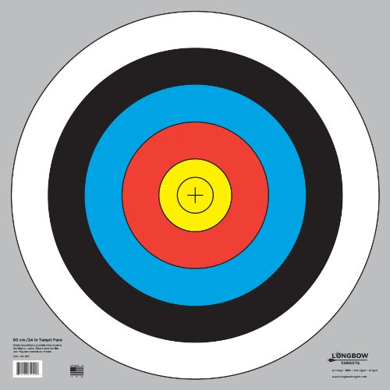
Archer No | Round 1
1
2
3
4
Total
Grand Total

2 4 6 8 10

Result and score …………………………………………………………………………………………………….

Team A ……………………………. Team B………………………………

Archer No | Round 1
1
2
3
4
Total
Grand Total
Archer No | Round 1
1
2
3
4
Total
Grand Total

2 4 6 8 10

Result and score …………………………………………………………………………………………………….

Team A ……………………………. Team B………………………………

Archer No | Round 1
1
2
3
4
Total
Grand Total
Archer No | Round 1
1
2
3
4
Total
Grand Total

2 4 6 8 10

Result and score …………………………………………………………………………………………………

